- talk about yourself

I started to learn computer programming when I was 12. Then I performed well in the National Olympiad in informatics, which is similar as ACM, and won the first prize. So I was admitted by SJTU, Shanghai Jiao Tong University, without entrance exam. Although programming training was a major part of my high school life, I showed a great interest towards Biology and Chemistry. That’s why I took both Computer science and pharmacy in SJTU.

Next, I joined the lab of bioinformatics in SJTU when I was a junior student and started to understand biological data using computer software. After completing undergraduate study, I decided to go further study and here I am. I am now a master student majoring in bioinformatics in Northeastern University.

That’s it!

-script

R to do data analysis. Machine learning

Python, easy to write, powerful modules, tensorflow to do machine learning.

Javascript Webdev

For now, I use python most because it is easy to write.

And because I am taking algorithm class now, so I use python to solve algorithm problems.

But I also use perl to do data processing, because perl performs pretty well and fast when if handles such things.

-projects

Web development

Now I am building a dynamic web app by **MEAN** stack using MongoDB, Express, Angular JS and Node.js.

I have done 4 steps:

1. User interface development, Bootstrap as my main CSS
2. Client side development, To make the page dynamic. Angular.js was used to implement data services, controllers and single page navigation.

The configuration will find the correct controller regarding url of certain pattern.

Data was simulated as arrays of objects in angular services.

Basically on this state, I refactored the static Website into a dynamic Single Page Application (SPA) using AngularJS. Static HTML web pages were refactored into dynamic angular views rendering data provided by angular controllers.

1. Server side development.

Focusing on creating Web services with the Express Node.js module.

Web services will expose server side data sources through HTTP endpoints. The angular services will access the data from the Web services through various HTTP requests like POST, GET, PUT and DELETE.

1. Database development.

In the previous one, the data lives in the server side service. Then I refractored to use data models instead of that mock data collections. Using mongoose data models and schemas to persist and interact with a MongoDB instance.

The communication with the database will be asynchronous using promises.

1. Security. What I haven’t done so far.

Using PassportJS to secure the APP

webdev-spring-gu-2017.herokuapp.com

1. to find unique kmers and then blasted them towards the DrosophilaAllchoms database.

Then calculated the offtarget numbers for each hit.

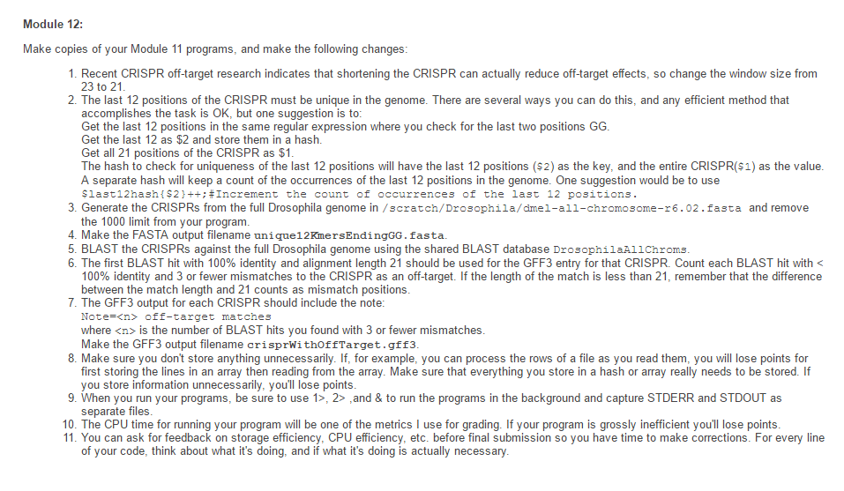

2. Drracket Lisp-Scheme language.

We are required to program in strict style PDP programming design paradigm.

For each function, we need have a purpose statement, examples, tests, design strategy, and definition.

implemented some algorithm thing using Drracket

Also UI things.

And the challenge is how to depict them well. If we have an edge from state 1 to state 2 and state 1 could receive letter a,b,or c to go to state 2. Then the question is how can I draw the edge beautifully with the notation a,b,c on it.

Two kinds of robots, a launcher for these two robots, goofballs around the map.

simulate the activities of the objects in the map.

They have some interactions.

SAGR meets a goofball -> DAGR

DAGR meets a goofball, both of them disappear.

3. shell interpreter

int main()

{

printf("**********************\n");

printf("* Welcome to myshell *\n");

printf("**********************\n");

head = malloc(sizeof(struct history_Node));

tail = malloc(sizeof(struct history_Node));

head->front = NULL;

head->next = tail;

tail->front = head;

tail->next = NULL;

while (true){

flag = true;

is_child = false;

STD_INPUT = dup(0);

STD_OUTPUT = dup(1);

printf("linux:~$ ");

gets(command_line);// get commands (no more than 3)

if (strcmp(command_line,"") == 0) continue;// if command is empty

//judge_exit();

if (strcmp(command_line,"exit") == 0)//if command is exit

{

history_delete();

printf("Thx for using!\n");

exit(0);

}

history_save();//save history

separate_command();// separate command with blank

separate_pipe();// separate command with |

separate_file();// separate command with > or <

judge_external();// judge

if (flag = true) judge_internal();

if (flag = true) printf("The command can not be found \n", command_line);

_clear();

}

return 0;

}



4. Course Registration

OOP Couse ID,place,instructor,credits, capacity.

interaction between objects.

MFC

-research

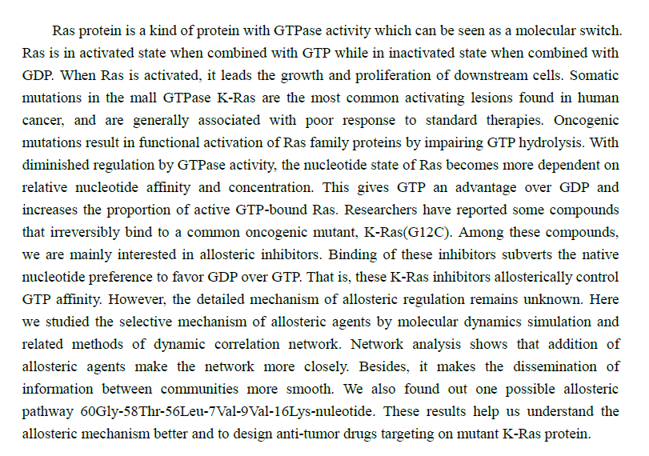

 However, the relationship between FBP and serine for allosteric regulation of PKM2 is unknown.